Burak Demirci
2201292
COP4493 - AWS Academy Cloud Computing Fundamentals
Project-1

URL of Website: lb-website-hosting-burakdmrc-1713133902.us-east-1.elb.amazonaws.com
AWS Account ID: 895084669974

GitHub Repository URL: https://github.com/burakdemirci03/cop4493_website

S3 Bucket Creation
- Bucket Type: Select “General Purpose”.
- Bucket Name: Any name to identify the bucket, I gave “s3-website-hosting-burakdmrc”.
- Other configurations can stay same, then proceed with “Create Bucket” at the end of the page.
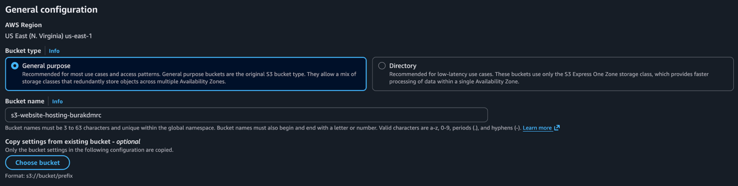
- After creating the bucket, select the bucket and then upload the HTML, CSS and JS files using top left button.
- Then go to “Properties” from top bar and find the Static Website Hosting in the bottom of the page. And click to “Edit” button.
- Static website hosting: Enable the radio button.
- Hosting Type: Select “Host a static website” area.
- Index Document: Set the same HTML file as the name. Mine was “index.html”, I set it so. If an error endpoint is given, it can also be named the same way.
- Don’t need to change anymore, so “Save Changes”.
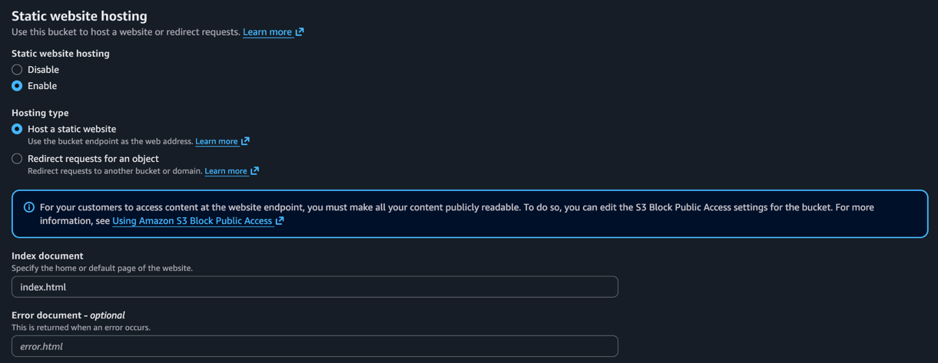

VPC Creation
- Resources to Create: Select “VPC and more”. So, while creating VPC, NAT and subnets are also created by AWS.
- Name Tag Auto-Generation: Enable “Auto-generate” and name anyway you wish, I named myself “vpc-website-hosting-burakdmrc”.
- IPv4 CIDR Block: I gave the address space as “10.128.0.0/16”. But any other suitable spaces can be given.
- IPv6 CIDR Block: Select “No IPv6 CIDR Block”.
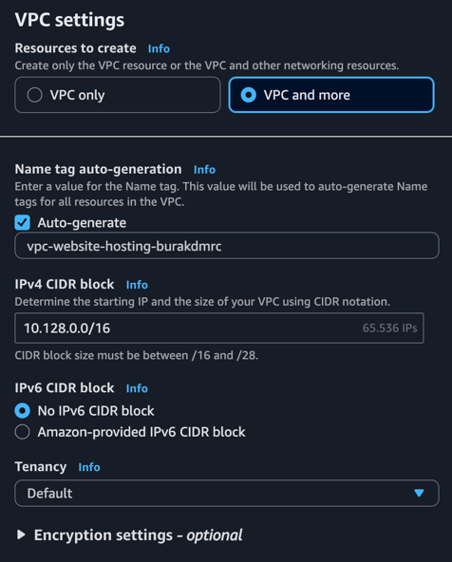
- Number of Availability Zones (AZs): Select 2. And choose two different AZs, I choose us-east-1a and us-east-1b.
- Number of Public/Private Subnets: Select 2 for both public and private subnets.
- Subnets CIDR Blocks: Is optional to modify. I named;
  - Public Subnet CIDR Block in us-east-1a: 10.128.0.0/24
  - Public Subnet CIDR Block in us-east-1b: 10.128.2.0/24
  - Private Subnet CIDR Block in us-east-1a: 10.128.1.0/24
  - Private Subnet CIDR Block in us-east-1b: 10.128.3.0/24
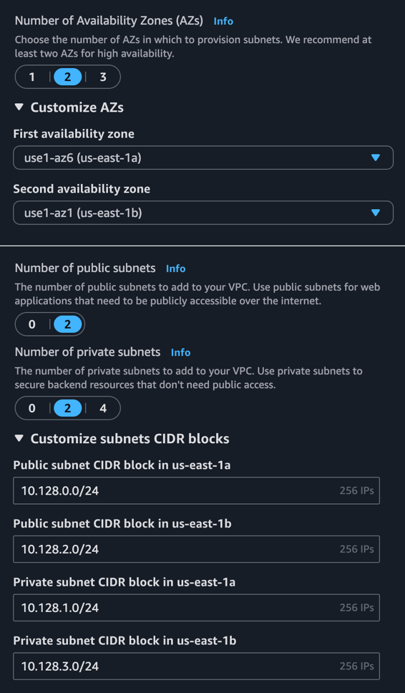
- NAT Gateways: Select “Zonal” first and then “1 per AZ” in order.
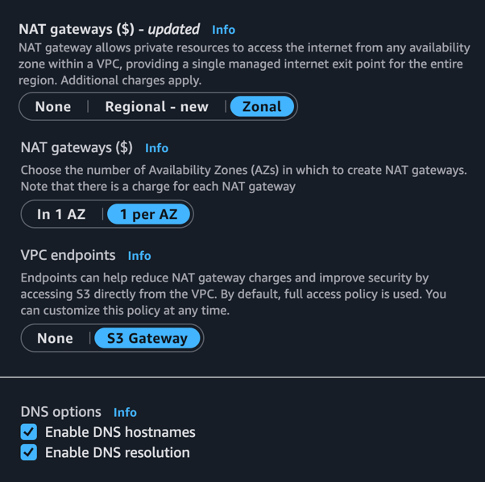
- Then proceed with “Create VPC” finally.

PS If I do remember correctly, the Subnets, Route Tables, Internet Gateway and NAT Gateways are also configured properly while creating the VPC.
If not configured automatically;
- for Route Table for Public Subnet: Any IPv4 address should target to the Internet Gateway (0.0.0.0/0 -> igw-xxxxxx).
- for Route Tables for Private Subnets: Any IPv4 address should target to its corresponding NAT Gateway (0.0.0.0/0 -> nat-xxxxxx).

EC2 Instance Creation
- Name: Select any name you prefer, I named “ec2-website-hosting-burakdmrc”.
- Amazon Machine Image (AMI): Do not need to change the default “Amazon Linux” and “Amazon Linux 2023 kernel-6.1 AMI” configuration.
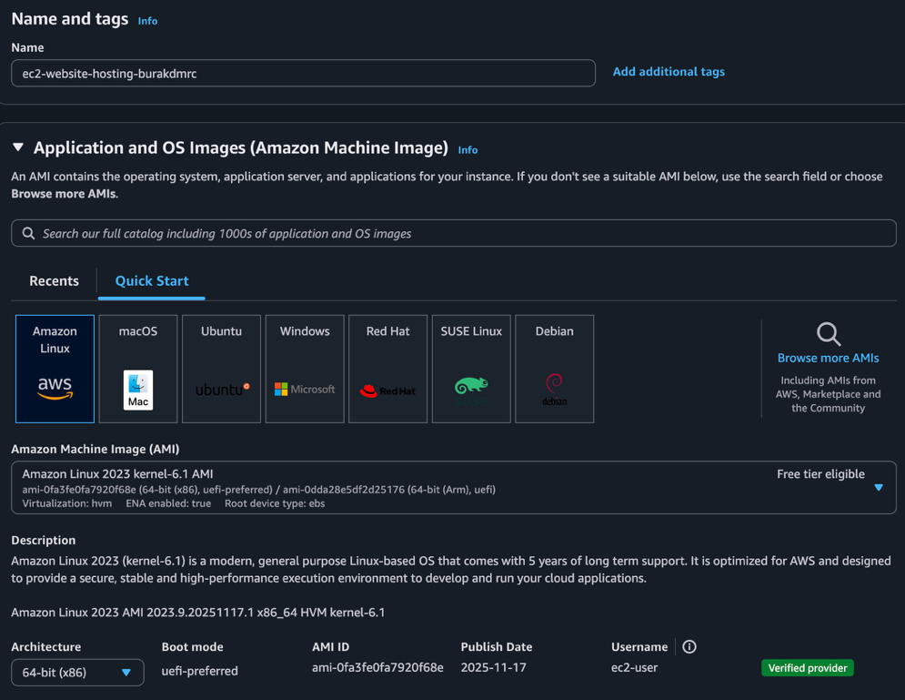
- Instance Type: The default t3.micro can also remain the same.
- Key Pair: Select “vockey”.
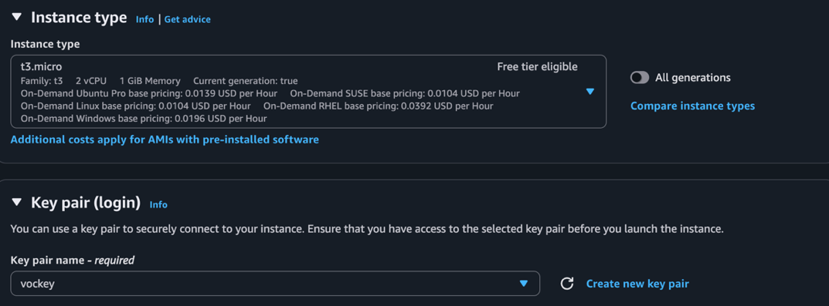
- VPC: Select the recently created VPC, “vpc-website-hosting-burakdmrc-vpc”.
- Subnet: Choose any private subnet of given VPC, I choose us-east-1a private subnet ”vpc-website-hosting-burakdmrc-subnet-private1-us-east-1a”.
- Auto-assign Public IP: Disable the setting.
- Firewall (Security Group): We do not have any security group yet so choose “Create Security Group”.
- Security Group Name: Name any way you prefer, I named “website-hosting-burakdmrc”.
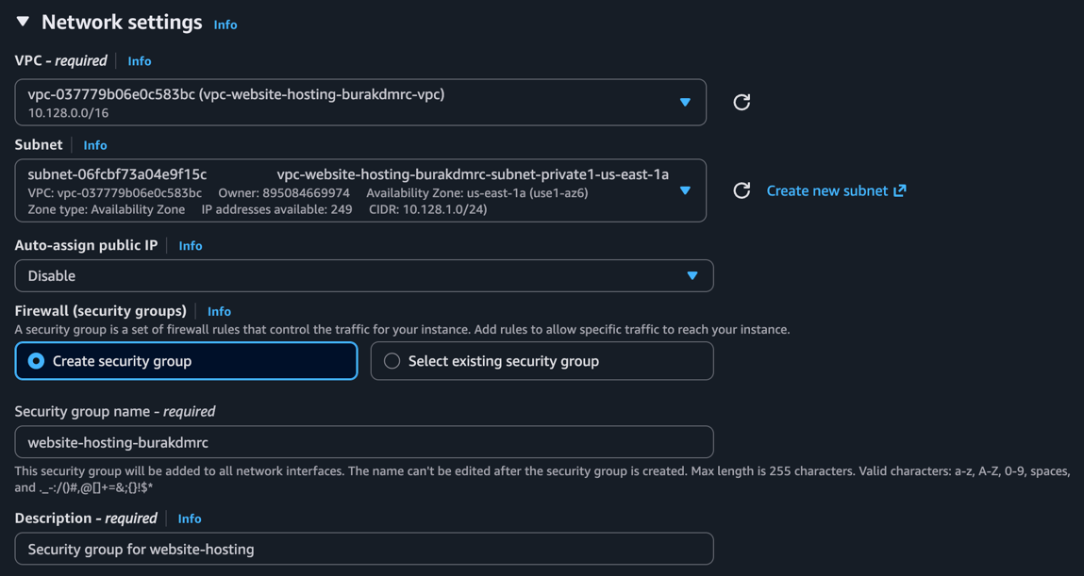
- Inbound Security Group Rules: Keep the default ssh rule (TCP, 22, 0.0.0.0/0) and add a new rule that takes the HTTP connection and target to Anywhere (TCP, 80, 0.0.0.0/0)
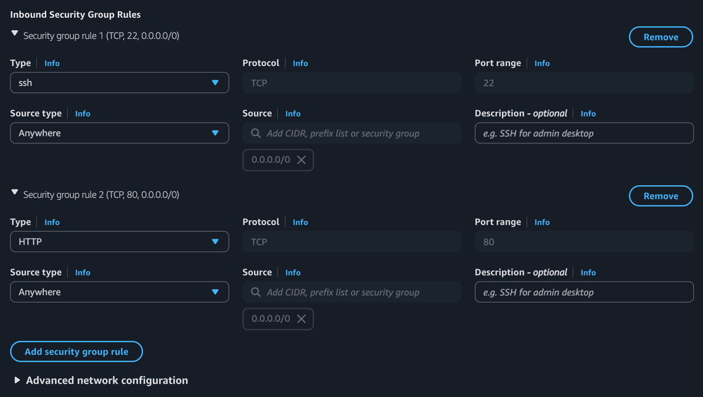
- Then launch the EC2 instance.

- We created this instance on only one subnet so, when created the first EC2 instance, select the created instance (given “ec2-website-hosting-burakdmrc”) and in top right bar select “Actions” and “Images and Templates”, then click “Launch more like this”. Then in opened tab;
- Subnet: Change the subnet to the other private subnet. I choose private1-us-east-1a in first instance, so in this instance I changed to ”vpc-website-hosting-burakdmrc-subnet-private2-us-east-1b”.
(I did not launch another instance, which would cost too much in long-term)

- In left scrollable are click “Target Groups”, then in top right click “Create Target Group”. We will need a target group in Load Balancer.
- Target Type: Keep the setting in Instances.
- Target Group Name: Give a unique name for Target Group, I gave “tg-website-hosting-burakdmrc”.
- Protocol & Port: Choose HTTP protocol and port 80.
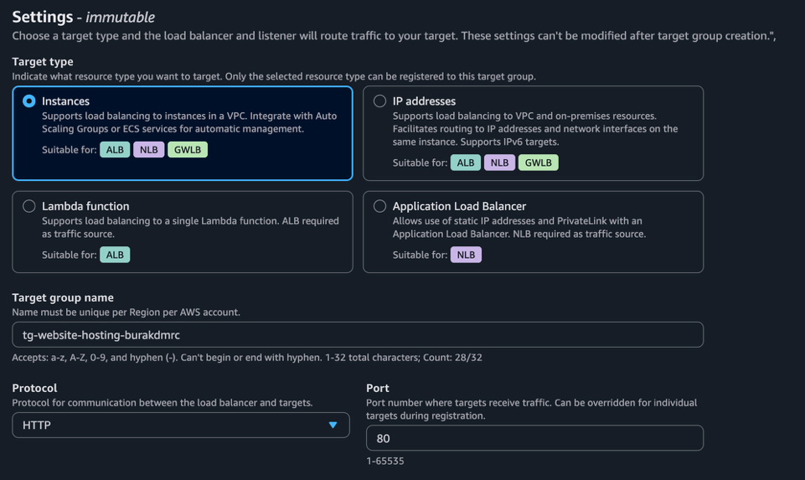
- IP Address Type: Keep in IPv4.
- VPC: Select the previous VPC, “vpc-website-hosting-burakdmrc-vpc”.
- Protocol Version: Keep on HTTP1.
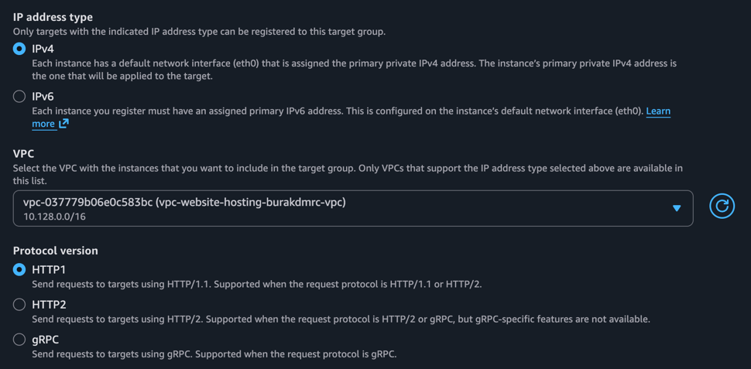
- Then proceed to “Next” page.
- Register Targets: Select the recently created EC2 instance, which was “ec2-website-hosting-burakdmrc” for me. Then click “Include as pending below” button and proceed to “Next” page where you would end up in “Create Target Group”.

- In left scrollable are click “Load Balancer”, then in top right click “Create Load Balancer”.
- Select Create from Application Load Balancer section in Load Balancer Types.
- Load Balancer Name: Give a unique name for Load Balancer, I gave “lb-website-hosting-burakdmrc”.
- Scheme: Select Internet-facing.
- Load Balancer IP Address Type: Choose IPv4.
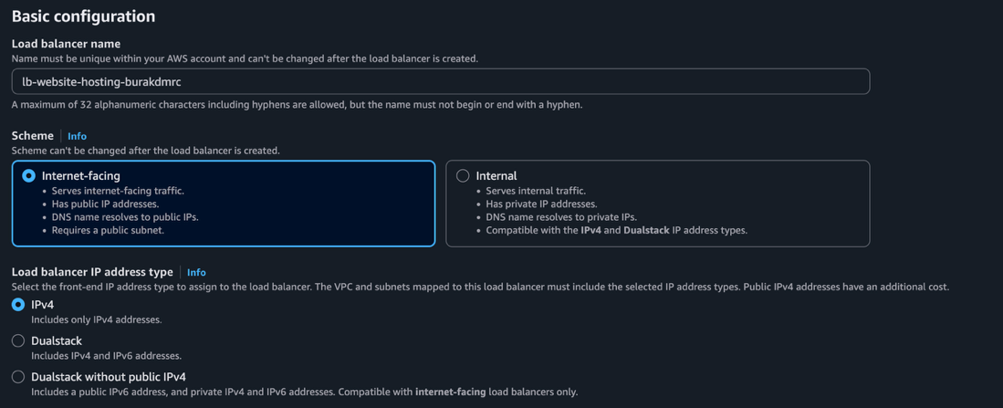
- VPC: Select the previous VPC, “vpc-website-hosting-burakdmrc-vpc”.
- Availability Zones and Subnet: Select both subnets and its corresponding public subnets ”vpc-website-hosting-burakdmrc-subnet-public[x]-us-east-1[x]”.
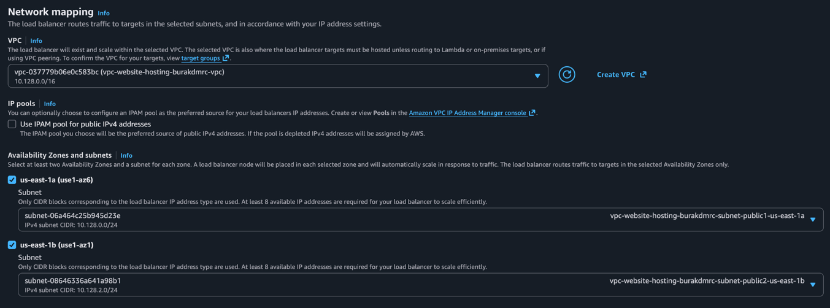
- Security Groups: Select the security group, which was created while creating VPC, for me it was “website-hosting-burakdmrc”.
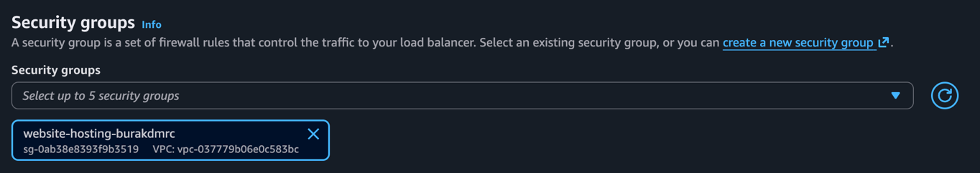
- Protocol & Port: Choose HTTP protocol and port 80.
- Routing Action: Select “Forward to target groups”.
- Target Group: Select the recently created target group, “tg-website-hosting-burakdmrc”.
(Since I have used target group before, I cannot choose it while showing in another instance)
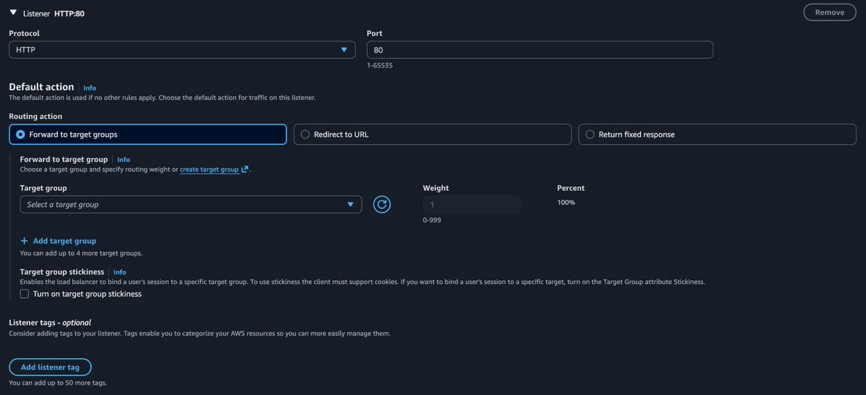
- Then continue with “Create Load Balancer” which is located the end of page.

Web Server Configuration
- Select the EC2 instance and click to the “Connect” button at the top-right corner.
- In instance connection try one of the following;
  - Go back to the instances page and select the instance, then proceed with Actions > Networking > Manage IP Address. Open up the collapsable Network Interface section (named like, “eth0: eni-[xxxx] - 10.128.1.0/24”) and turn on the “Auto-assign Public IP” option and Save. Then go back to Connection tab, select “EC2 Instance Connect” and “Connect using a Public IP”.
(turn off the “Auto-assign Public IP” when all configuration are done)
  - Connect with “SSH Client” using the instruction in readme manual on AWS Academy website.
  - If possible, connect using “Session Manager”.
(while doing project, most of time this option was not open for me but now it is open, even if I do not know why)
- Create the Apache Server using following instructions;
sudo yum update
sudo yum install httpd
sudo systemctl start httpd
sudo systemctl enable httpd
- Then load the objects -HTML, CSS and JS files- from S3 to the Apache server using;
sudo aws s3 sync s3://s3-website-hosting-burakdmrc /var/www/html

Website should be accessible by the DNS record of the load balancer now!

